Harness Measuring Chart

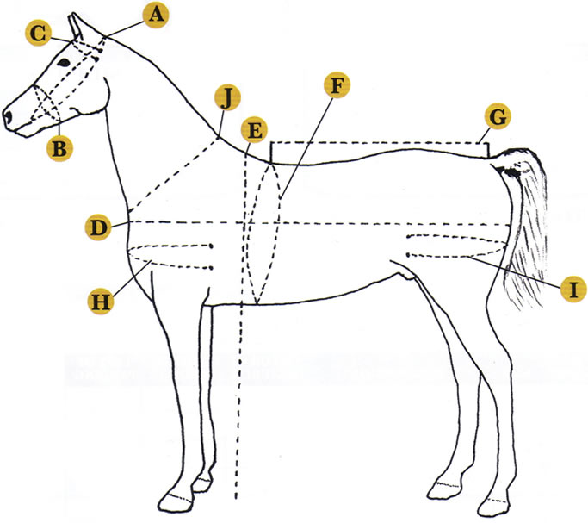

- Poll
- Nose Circumference
- Brow
- Body length
- Height to Top of Withers
- Girth
- Topline length
- Chest
- Butt
- Neck

Compilments of Chimacum Tack

